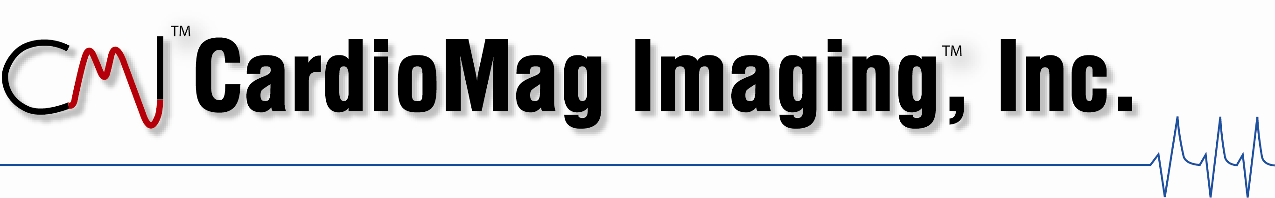

Magnetocardiography for Heart Wellness Screening

A screening test must be accurate, reproducible, and provide information that can lead to a recommended course of action, suggest therapy or provide a prognosis.

Non-invasive tests like echocardiography and the 12-lead ECG lack sufficient sensitivity to be useful screening tools for cardiovascular disease in asymptomatic individuals, and too often they have the potential of giving an individual a false sense of security as a result of their low sensitivity. There are many cases of individuals who, days after a negative ECG exam, have suffered a life-threatening heart attack.

On the other hand, performing a cardiac computed tomography (CCT) scan to determine a coronary artery calcification score (CACS) for risk assessment in certain populations remains controversial. Whereas CACS (CCT) was included in a new screening paradigm recommended by the SHAPE Task Force (SHAPE = Screening for Heart Attack Prevention and Education), it was deemed Inappropriate for Risk Assessment of individuals at low risk of CHD (Framingham criteria) by a different multi-society panel. This panel also did not endorse CACS for risk assessment of asymptomatic medium and high risk CAD patients.

In the development of their recommendations the panel considered, among other things, the exposure of the patient to radiation. CCT is appropriate for many indications, especially for the detection of CAD in the evaluation of chest pain of a symptomatic population with intermediate pre-test probability of CAD. However, for the asymptomatic population there appears to be a pressing need for a radiation-free, high sensitivity test for the detection of CAD in all risk categories.

Magnetocardiography fills that need by measuring and displaying the 4-D homogeneity of cardiac electrical activity in an entirely non-invasive, radiation-free exam. The relationship between homogeneity of the MCG during ventricular repolarization and underlying cardiac ischemia continues to be documented in trial after trial.

Equipped with the world’s most sophisticated magnetic field sensors, the magnetocardiograph (left hand picture below) measures and displays the cardiac magnetic field (color map in right hand picture below) and calculates the effective magnetic vector (gray arrows in right hand picture below) during any part of the cardiac cycle. During ventricular repolarization the homogeneity of these vectors is directly related to underlying ischemic heart disease.

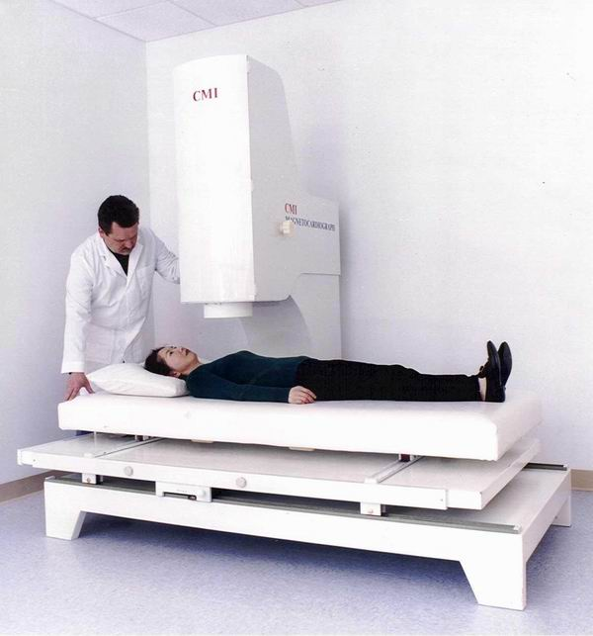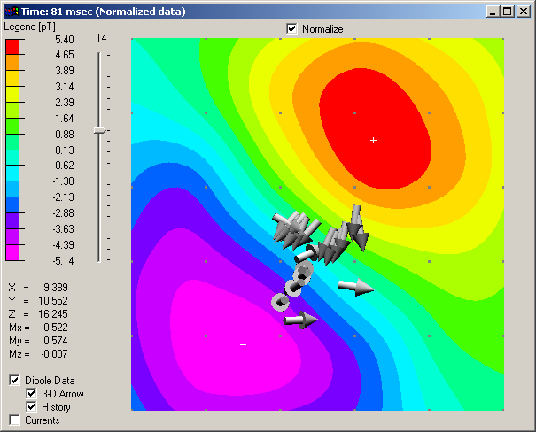

In the case shown the ECG was normal, the cardiac enzymes were normal, blood pressure was normal and cholesterol normal. Only the MCG identified the abnormal condition with coronary angiography revealing two-vessel disease.

Since functional problems can exist in the absence of anatomical “damage” such as calcification and obstructive coronary artery disease, MCG provides a true early warning, perhaps even evidence of subclinical arterial disease.

Frequently asked Questions

Is the MCG scan reimbursed by health insurance?
The MCG is a self-pay test and the patient should contact his/her insurer to see if the costs of an exam will be reimbursed.

What is involved in an MCG exam?
A patient lies down on a bed and highly sensitive antennas are lowered as close as possible to the chest, right above the heart. During the next eight to ten minutes these antennas measure the magnetic fields (similar in shape to an ECG trace) generated during the cardiac cycle. The stored MCG data are analyzed and the results are available immediately in a printed report which includes a quantitative assessment of the risk of having ischemic heart disease.

How often can one take an MCG exam?
Because MCG uses no radiation and is entirely non-invasive, one should have an MCG exam as often as necessary.

Is there an age when one should have an MCG exam?
An individual’s first MCG exam provides a so-called baseline MCG test against which all future tests can be compared. It can be taken at any age, but the earlier the better, especially when the individual is presumably at “peak” health. Subsequent tests are compared to the baseline, thus giving the individual a way to monitor cardiac function all life long.

Can children have an MCG exam?
There is no lower age limit for an MCG exam.

Are there any individuals who should not take an MCG exam?
Individuals who are not able to lie down cannot take an MCG exam. Pacemakers create electrical signals that interfere with the MCG measurement; therefore, patients with pacemakers are not advised to take an MCG exam. However, MCG operation does not interfere with pacemaker function, and individuals with pacemakers are safe in the presence of MCG equipment.

Where is the MCG being used today?
In the United States, CMI 2409 MCG systems are being used at the Mayo Clinic (Rochester, Minnesota) and at Cedars-Sinai Medical Center in Los Angeles, California.

Operating Costs – The price of the MCG system, an annual service and maintenance agreement and servicing the associated debt over five years amounts to a cost of approximately $300 per day. The costs of space and personnel to run the equipment vary from location to location. There are no special installation constraints like those encountered with MRI or X-ray equipment.

MCG Exam Reading – An individual must complete a course in the reading and interpretation of magnetocardiograms. The individual need not be a cardiologist, but should have sufficient training in cardiovascular physiology and cardiac electrophysiology. The course lasts four weeks, and can be conducted at the screening center, if necessary. The cost of training the Reader for the first time is included in the price of the MCG system.

MCG Technician/Operator – An individual with the appropriate technical background (to be specified by CMI) must complete a course in the operation of the MCG system and in how to conduct an MCG exam. The course lasts four weeks and can be conducted at the screening center, if necessary. The cost of training the Operator for the first time is included in the price of the MCG system.

The MCG has been approved by the FDA (K033488) for the measurement of the magnetic fields created by the electric activity of the heart. A global scientific and clinical community is continuously providing proof through published literature that the MCG adds significant value to the diagnosis and treatment of a wide range of cardiac diseases. While an MCG exam is safe and presents no health risk to an individual, only the performance of randomized clinical trials will deliver the scientific evidence demonstrating the value of a screening strategy using MCG.

For more information, please contact

Robert Sokolowski
VP Business Development
CardioMag Imaging, Inc.
450 Duane Avenue
Schenectady, NY 12304

Telephone: 518-381-1000
FAX: 518-381-4400
Mobile: 518-331-3998

Amer. Jrl. of Card., Vol.98(2A), 2006, “From Vulnerable Plaque to Vulnerable Patient – Part III: Executive Summary of the Screening for Heart Attack Prevention and Education (SHAPE) Task Force Report”
JACC, Vol.8,No.7,2006, “ACCF/ACR/SCCT/SCMR/ASNC/NASCI/SCAI/SIR Appropriateness Criteria for Cardiac Computed Tomography and Cardiac Magnetic Resonance Imaging”
ANE, July, 2005, Vol.10,No.5, Park et al., “Magnetocardiography Predicts Coronary Artery Disease in Patients with Acute Chest Pain”

